**Logic gates (3)**

**Name class**

**Example: Draw the truth table, show that the three circuits can be used to represent AND,OR,NOT gate**

QQ截图20151021112318.png

|  |  |  |
| --- | --- | --- |
| A | B | X |
|  |  |  |
|  |  |  |
|  |  |  |
|  |  |  |

what simplified design could replace the whole logic circuit.

____________________________________________________________________

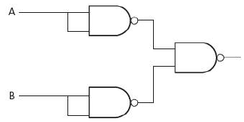

|  |  |  |
| --- | --- | --- |
| A | B | X |
|  |  |  |
|  |  |  |
|  |  |  |
|  |  |  |

what simplified design could replace the whole logic circuit.

____________________________________________________________________

QQ截图20151021112355.png

|  |  |
| --- | --- |
| A | X |
|  |  |
|  |  |

what simplified design could replace the whole logic circuit.

____________________________________________________________________

Exercise

1. Show how the following logic circuit could be built using NAND gates only. Complete the truth table for the logic circuits.

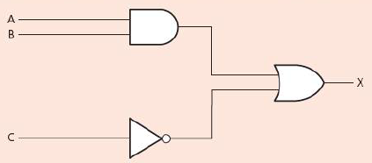

|  |  |  |  |  |
| --- | --- | --- | --- | --- |
| INPUT | | | Output from original circuit | Output from NAND gate only circuit |
| A | B | C |
|  |  |  |  |  |
|  |  |  |  |  |
|  |  |  |  |  |
|  |  |  |  |  |
|  |  |  |  |  |
|  |  |  |  |  |
|  |  |  |  |  |
|  |  |  |  |  |

1. Show by drawing a truth table which single logic gate has the same function as the following logic circuit made up of NAND gate only.

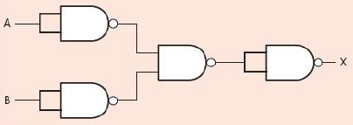

|  |  |  |
| --- | --- | --- |
| A | B | X |
|  |  |  |
|  |  |  |
|  |  |  |
|  |  |  |

what simplified design could replace the whole logic circuit.

____________________________________________________________________

1. Show by drawing a truth table which single logic gate has the same function as the following logic circuit.

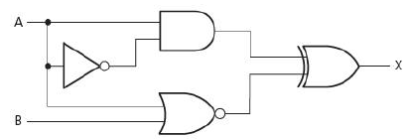

|  |  |  |
| --- | --- | --- |
| A | B | X |
|  |  |  |
|  |  |  |
|  |  |  |
|  |  |  |

what simplified design could replace the whole logic circuit.

____________________________________________________________________

4. Prove the following equation

**(x+y)’=x’y’**

**(xy)’=x’+y’**

5

1. Complete the table to show the outputs for the possible inputs to this circuit.

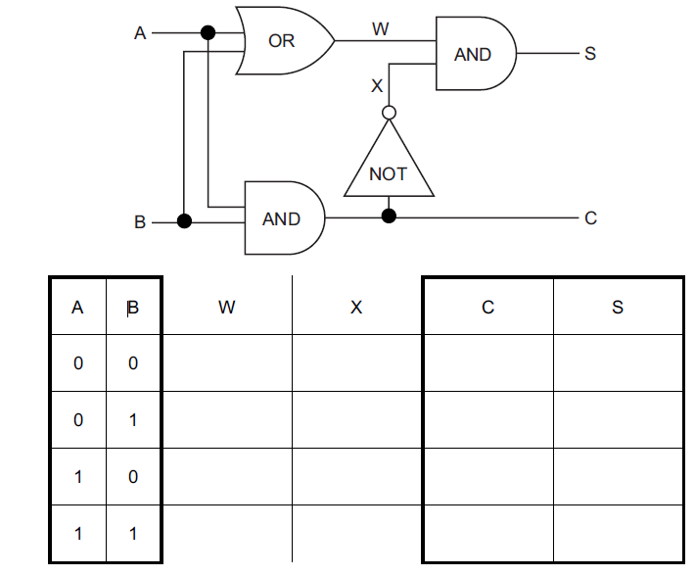

(b) State a possible use for this circuit in a processor.

____________________________________________________________________